Advanced World History NAME:
Mrs. Faulhaber DATE:
Vocabulary for Indus River Valley Civ PER: 1

Chapter 4 Themes:
- Knowledge of agriculture built the great cities of Mohenjo-Daro and Harappa, both which were noted for their productive agricultural economies but also for sophisticated societies of Dravidian peoples who traded with Mesopotamia.
- The merging of Aryan and Dravidian traditions causes some conflict, but the resulting caste system provides unique Indian identity while distinct religious beliefs facilitated by writing taught religious and spiritual information about life, ethics and behavior.

RELIGION---later becomes foundation for Hinduism

-VEDAS

-Rig Vedas

-UPANISHADS

-Brahman

-monism

-samsara

-reincarnation

-dharma

-karma

-yoga

-moksha

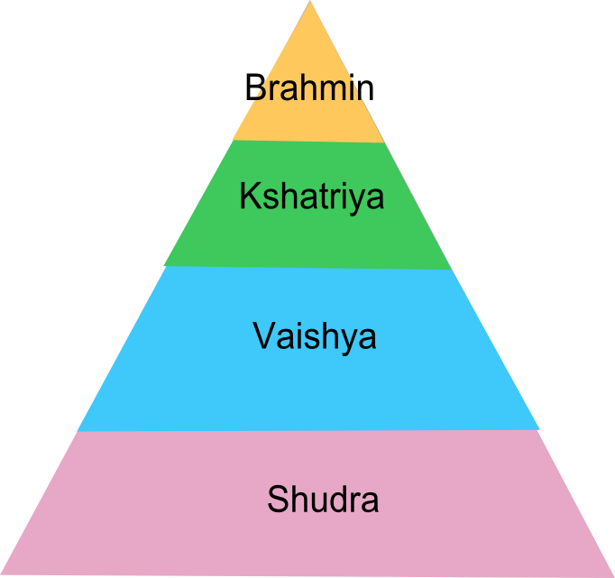

Pariahs = Untouchables

