Foundations of Government Name_______________________________
Citizenship Test Requirement Packet
Mr. Faulhaber Class Period: _______________
(Former) Justice David Souter on Civic Knowledge (from 3:25 until 6:36) Video Notes
http://www.msnbc.com/rachel-maddow/watch/perils-of-eroded-civic-knowledge-forewarned-790540867791?cid=sm_fb_maddow
_________________________________________________________________________________________________
_____________________________________________________________________________________________________________________________________________________________________________________________________________________________________________________________________________________________________________________________________________________________________________________________________________________________________________________________________________________________________
Include a quote or anecdote from the presentation that you found insightful and explain why you choose it. _____________________________________________________________________________________________________________________________________________________________________________________________________________________________________________________________________________________________________________________________________________________________________________________________________________________________________________________________________________________________________
What was his theme or message? How does his theme or message relate to the course syllabus?
_____________________________________________________________________________________________________________________________________________________________________________________________________________________________________________________________________________________________________________________________________________________________________________________________________________________________________________________________________________________________________
Civics Education Bills Are on Legislative Agendas in Seven States By Guest Blogger Sasha Jones
While most states require students to study civics in some sort of capacity, just eight mandate a yearlong civics or government class as a graduation requirement. But that number may soon grow as a flurry of civics education bills inch through state legislatures this year and other states move to expand or implement civic education requirements already in place. Education Week's survey last year found three states—Washington, Nevada and Pennsylvania—that are already on board to begin expanding their civics requirements as soon as this year. Seven other states are set to consider civics education bills introduced since the new year began.

Although the way that civics is covered in schools—and what is included—varies from state to state, the most common approach is the Joe Foss Institute's Civics Education Initiative, which calls for high school students to pass the 100-question test required to acquire U.S. citizenship.

With a 38 to 31 vote, the South Dakota House of Representatives passed a bill in that would require high school students to take that test, and score at least a 70 percent, to graduate. Although the Senate has since deferred the bill, if it passes, testing would start in the 2019-20 school year. Indiana lawmakers have introduced a similar bill in their Senate, which would make the civics exam a requirement starting in the 2020-21 school year if it's approved.

Although Tennessee already requires that students take a civics exam, a new bill is calling for the exam to be expanded from 25-50 questions to 100. Additionally, students would have to answer 75 percent—instead of 70 percent—of the questions correctly to graduate.

Some states are going beyond the citizenship test to implement legislation that could potentially affect more specific curriculum changes. In Minnesota, state representatives have drafted legislation that would require juniors or seniors to take a for-credit civics class as part of the three-and-a-half social studies credits they are currently required to earn in high schools. Although the state already requires that students take a 50-question civics test, the exam is not currently a graduation requirement. The Minnesota Department of Education will, however, use data from the current exam to assess students' civics knowledge.

A bill that would add civic responsibility to middle and high school curricula in North Carolina is currently working through the state's House of Representatives. While it is uncertain what the final requirements would consist of, the bill says that instruction would focus on respect for school personnel, responsibility for school safety, service to others, and good citizenship.

In Nebraska, a bill to change the name and provisions related to the Committee on Americanism to the Committee on American Civics would also shape education as the new committee would review and approve social studies curricula to stress civics and government. The current proposed bill also states that the curriculum would incorporate "multicultural education."

Additionally, California has stated its intent to enact future legislation related to civics education in a February assembly bill. (The state already requires students to take a one-semester civics and government class in order to graduate from high school.)

On the federal level, Senators Jim Inhofe (R-Okla.), Angus King (I-Maine), and Chris Coons (D-Del.) introduced the Constitution Education Is Valuable in Community Schools (CIVICS) Act of 2019 to Congress, which would aim to "improve the quality of student achievement in, and teaching of, American history, civics, government, or geography in elementary and secondary schools," as well as educate students about the history and principles of the Constitution and Bill of Rights.

“Should Montana require high school seniors to pass the U.S. Citizenship Test in order to graduate?”
Require citizenship test in schools: The exam can provide a floor on civics learning. It doesn't have to set the ceiling.
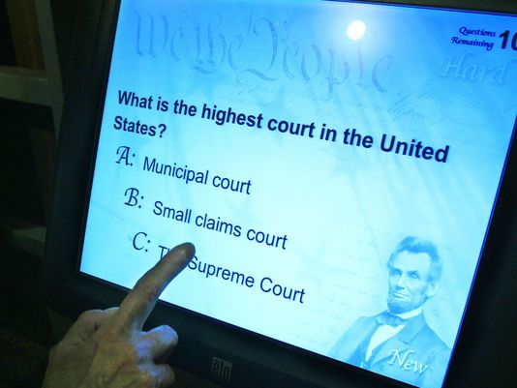
Jay Leno's old Tonight Show man-on-the-street quizzes were particularly hilarious — and depressing — when he tested Americans' knowledge of their own government.
One woman thought the colonies won their independence from Greece; a college instructor guessed that U.S. independence was won in 1922; and a man said the general who led our troops in the Revolutionary War was Winston Churchill.
Funny stuff, until you remember that these are the same citizens who elect the leaders who shape the nation's future, if they bother to vote at all. Nor are these know-nothings outliers.
Surveys and tests repeatedly show that Americans' knowledge of civics is pathetic. In 2010, just one in five eighth-graders tested proficient in civics on a national performance assessment — worse even than their dismal performance in reading and math.
A poll of Millennials, out last week, found that 77% of these 18- to 34-year-olds could not name even one of their home state's U.S. senators.
A 2012 survey of adults by Xavier University found that one in three native-born citizens failed the civics portion of a test given to immigrants seeking U.S. citizenship. The pass rate for immigrants: 97.5%.
So a decision last month by Arizona and North Dakota to require high school students to pass that same 100-question test to graduate is a welcome acknowledgment of the problem.
Like just about everything else in education, however, their simple idea is becoming contentious. It is under attack as yet another test-prep intrusion on education that could prompt schools to dumb down civics education — if that's possible.
Students used to master the basic workings of government in grade school. But in the past 20 years, civics has been eclipsed by a focus on reading, math and science, made even more intense by the No Child Left Behind law, which mandated annual tests in these subjects.
Fortunately, an eclectic group of leaders from government, education and the arts, including retired Supreme Court justice Sandra Day O'Connor, has championed a return to civics. They're making progress. Today, almost all states require civics classes in high school. About half the states already test students on civics or social studies.
Arizona and North Dakota, the first states to introduce the citizenship exam to schools, are not among them, but they at least now have a tool teachers can use.
Some questions are easy or trivial. But many about voting, the First Amendment, states' rights and the Supreme Court offer jumping-off points for enticing discussions about current events. In the hands of a good teacher, they can make students realize how much the American system of government affects their lives. The test can provide a floor on civics learning. It doesn't have to set the ceiling.
When just 26% of Americans can name the chief justice of the United States, there's nowhere to go but up.
=USA TODAY's editorial opinions are decided by its Editorial Board, separate from the news staff.
Directions: From the article you just read and highlighted above, list 3 reasons to SUPPORT Montana requiring the citizenship test to graduate.
Option 1: Reasons to Support the Citizenship Test Requirement | Reason 1:
Reason 2: | Reason 3:

Good citizenship transcends a test: It's not a matter of memorizing some random information.
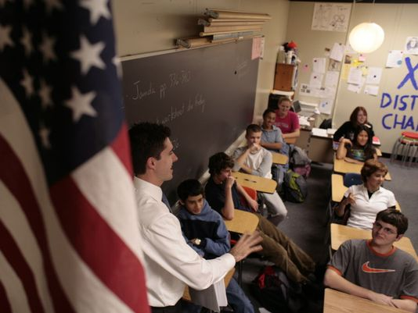
Requiring students to pass the citizenship exam will reduce both the amount and the quality of civic education in our schools.
The test is easy. You can see all the questions and answers in advance and just memorize the right choices.
If passing this exam comes to be seen as adequate preparation for citizenship, schools will notice that their students can pass after cramming for a couple of hours. They will cut their semester-long civics courses as unnecessary preparation. They will prefer to dedicate that semester to math or science, which involve much more sophisticated and challenging tests.
Requiring the citizenship exam would make sense if our students didn't already study civics or face tests. It would establish a floor, a minimal level of competence. But more than 90% of recent high school graduates have spent a semester in a civics course, and most have also spent a year on U.S. history. Their teachers gave them tests. In many states, they also faced a standardized test on civics or social studies.
Then why do so many adults fail basic questions about the U.S. political system? Because we have forgotten what we learned in civics class. Too often, the subject wasn't inspiring or challenging and didn't build habits of following and discussing the news.
The problem with civics is not that we fail to teach it. The problem is that civics is often viewed as a set of disconnected facts, not as a challenging and inspiring subject that will continue to interest us after high school.
Arizona's measure requiring that students pass the citizenship test will make that problem worse. The citizenship exam requires, for instance, that you know that "27" is the correct answer when you're asked how many constitutional amendments have been passed. You don't need to understand reasons for or against those amendments, or have any sense of why they were important.
A month after students pass this test, they will forget the number 27. But they might retain the message that being a good citizen is a matter of memorizing some random information. That seems like an excellent way to turn people off.
Peter Levine is associate dean for research at Tufts University's Jonathan M. Tisch College of Citizenship and Public Service.

Directions: From the article you just read and highlighted above, list 3 reasons to OPPOSE Montana requiring the citizenship test to graduate.
Option 1I: Reasons to Oppose the Citizenship Test Requirement | Reason 1:
Reason 2: | Reason 3:
Idiot (idiotes) was a term of reproach in ancient Greece reserved for persons who paid no attention to public affairs and engaged only in self-interested or private pursuits, never mind the public good. Puberty today refers to the transfer to adulthood from childhood but its origin comes from the word public which referred to the transition into public life from narcissistic pursuits. Democratic living is not given in nature, like gold or water. It is a social construct like a skyscraper, school playground or new idea. Democracy’s basic tenets include; individual liberty, equality, and popular sovereignty. Among those, popular sovereignty or self-governing is democracy’s defining attribute.
Accordingly, there can be no democracy without its builders, caretakers and change agents: democratic citizens. These citizens are to determine the policy formation, direction of the public agenda, and size and scope of the government.
Thomas Jefferson famously said: “If we're going to have a successful democratic society, we have to have a well-educated and healthy citizenry.” Developing citizens capable of making rational decisions in public policy contexts means embracing individual differences, listening, avoiding egocentric or ethnocentric distortion, and acting as a change agent not a spectator of policy formation. Consequently, democracy requires the idiot who has not yet met the challenges of puberty to throw off self-interest and think rationally as a part of the social community and transition to public life and become a citizen.

Today, many people believe the primary purpose of “public” education is to prepare students for college and/or their future occupation, and the social sciences are no longer emphasized. The results have been predictable; students are illiterate in their knowledge of history and civics. Students no longer can even pass a civics competency test or even the citizenship test we require immigrants to pass because we feel its fundamental knowledge is so vitally important to participating within our democracy.

Consequently, policymakers have sounded the alarm and many schools have subsequently required passage of the aforementioned citizenship test to graduate, a specified amount of community service hours to graduate, or a combination of both. The end goal, of course, is to produce citizens competently capable of fulfilling their democratic obligations such as voting, serving on a jury, and being an active member of his/her community. Critics, however, argue that none of these plans are a solution to the problem and instead of developing informed citizens, they breed resentment. What everyone does agree upon, though, is that something needs to be done.
How do we create better citizens capable of not only exercising their rights but fulfilling their responsibilities?

Public education in America was originally intended to prepare students for the obligations of democratic citizenship. Today, many people believe its purpose is to prepare students for college and/or their future occupation.

Knowing that people do not traditionally give money without expecting something in return i.e. you pay $1 for a pop or candy bar in a vending machine but if you didn’t get a pop or candy bar when you put the $1 in the machine you would quickly quit spending your money. If not for a well-informed citizenry that can competently and willingly fulfill their civic duties because of their free education paid through taxes, why should the public pay taxes for your education? What should the public get in return and what do they get in return?
__________________________________________________________________________________________________________________________________________________________________________________________________
_________________________________________________________________________________________________
__________________________________________________________________________________________________________________________________________________________________________________________________
Not every school, school district, or state has the same requirements for graduation. Other than a Citizenship Test passage to graduate, which of the following proposals, if any, would you support to increase civic competency? (Rank these in the order of their importance with 1 being the highest): ___More Social Science Classes offered and the classes start earlier in High School
___Increase in Social Science Credit Requirements for Graduation
___Community Service Requirement with passage of the Citizenship Test to Graduate
___Community Service Requirement to Graduate instead of passage of the Citizenship Test
___Status Quo: There is no problem so no solution is needed
___other: __________________________________________________________________________________________
Justification for your ranking:
_____________________________________________________________________________________________________________________________________________________________________________________________________________________________________________________________________________________________________________________________________________________________________________________________________________________________________________________________________________________________________

When I asked my Parent(s)/Guardian(s)/Sibling(s)/Adult(s) in my life the deliberation question, and discussed with him/her/them what I had written on this page I was told....I agree/disagree because… my final thoughts on Montana requiring passage of the U.S. Citizenship Test to graduate are…
_________________________________________________________________________________________________________________________________________________________________________________________________________________________________________________________________________________________________________________________________________________________________________________________________________________________________________________________________________________________________________________________________________________________________________________________________________________________________________________________________________________________________________________________________________________________________________ Parents/Guardians/Adult in my life Initials:

